Samuel Raumin

ECE 3010

January 29, 2020

Exercise 1 Week 2

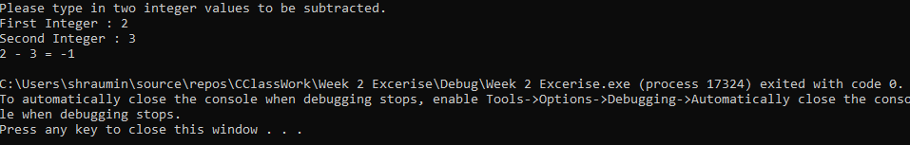

#include <iostream>

using namespace std;

int main() {

int a, b, final;

cout << "Please type in two integer values to be subtracted. \n" << "First Integer : ";

cin >> a;

cout << "Second Integer : ";

cin >> b;

final = a - b;

cout << a << " - " << b << " = " << final << "\n";

}